Beginner Intermediate
Sketch it out! Drawn and label!  Directions: Write a noun to draw and label. Then, make your noun plural!  Example:  noun plural noun  dog dogs  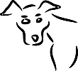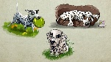  Try It!  noun plural noun | Sketch it out! Drawn and label!  Directions: Write a noun to draw and label. Then, make your noun plural!  Example:  noun plural noun  dog dogs  Try It!  noun plural noun  noun plural noun  noun plural noun  Write a 7-Up Sentence using both words!  Example: The shy dog sat and watched the other dogs play together.

